Family-hub(Vainateya prathmik vidyamandir niphad)
Roles
Teacher, student, parent, admin

Admin
1 create new users
Input – role
If role is teacher input – name , mail, mobile no
If role is student input – students detail[• नाव (Name)
• आय.डी. क्रमांक (ID No.)
• जन्मतारीख (DOB)
• नोंदणी क्रमांक (Reg. No.)
• रोल नंबर (Roll No.)
• वडिलांचे नाव (Father’s Name)
• आईचे नाव (Mother’s Name)
• मातृभाषा (Mother Tongue)
• माध्यम (Medium)
• पत्ता (Address)
• ईमेल
• मोबाईल क्रमांक (Mobile No.)
• UDISE क्रमांक]
Output – new user – should create the user as new user login with given email that was the input and demo password for now
2 view all users according to the roles and can delete the users
3. view admission enquires from the enquiry form

ATTENDANCE MODULE
Teacher fill attendance
Student , parents view own attendance, teacher view class attendance, teacher can download monthly attendance sheet in pdf format:
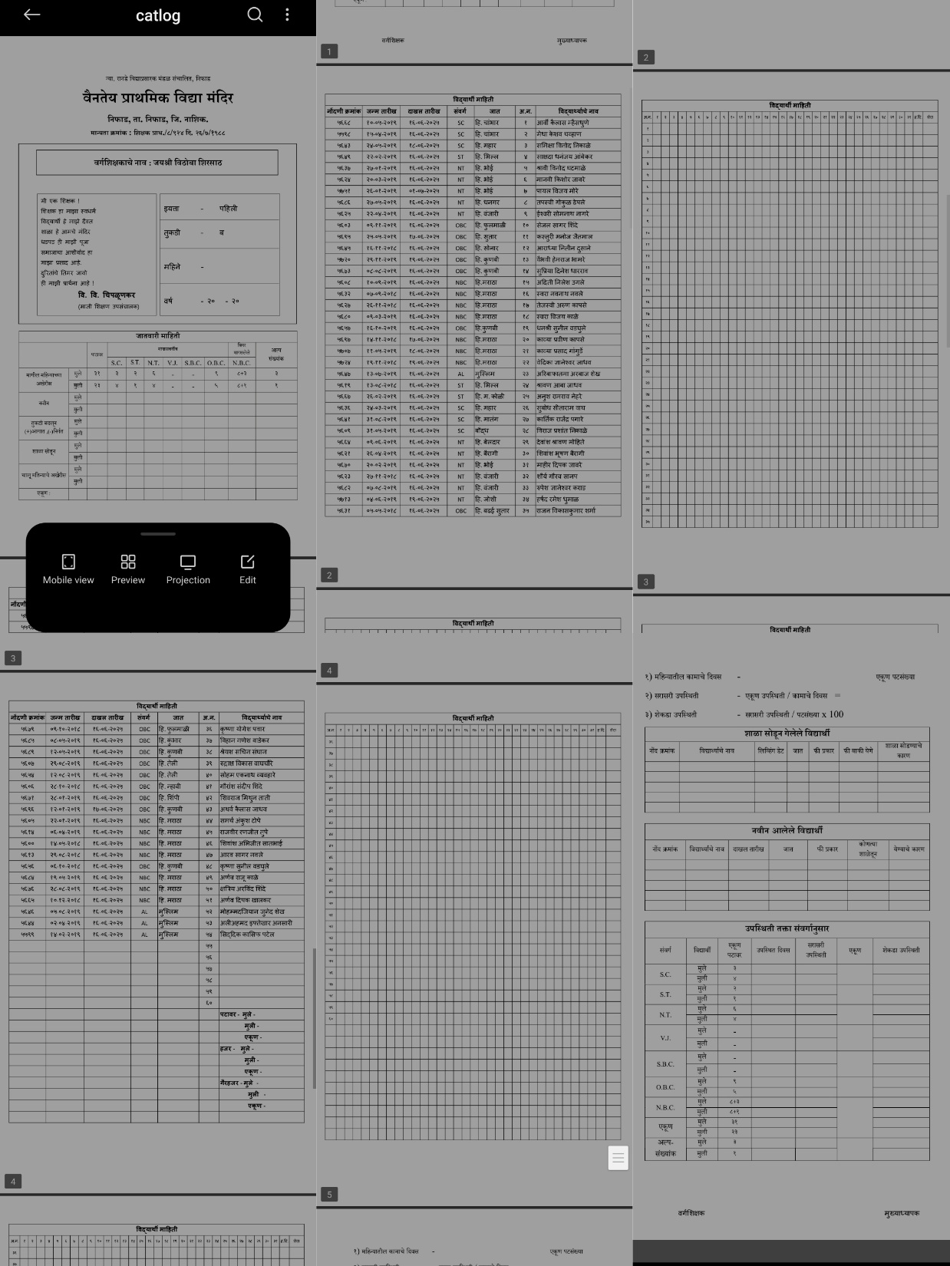
Tables on first and last page should be blank all other details should be filled

QUIZ MODULE
Teacher can add questions and publish quizzes
Students can see and take quizzes on submission view marks
Teachers can view marks of all the student in the class

REPORT CARD MODULE
Teachers can generate printable report cards of each individual student format is as given below inputs should be fields in the below mentioned report card, the student details are already in the database as they should be taken during adding new student .
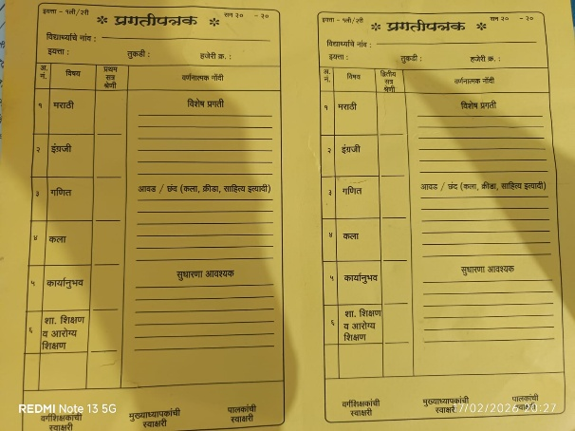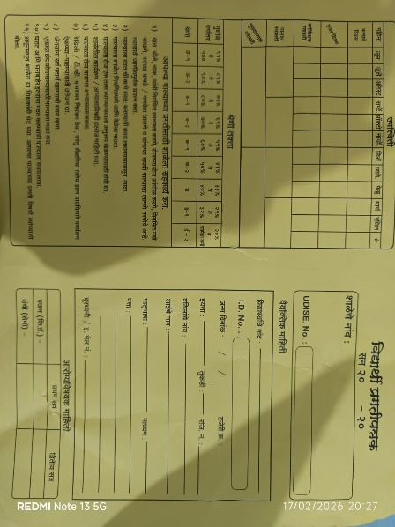

MEETINGS MODULE
Teachers should be able to schedule meetings ptms
Parents should get notify about the upcoming meetings and view their meeting schedule
Teachers should be able to cancel or reschedule

